**SOFTWARE REQUIREMENT SPECIFICATION FOR**

**INSTANT HIRE**

**[21-11-2020]**

**CDAC, KHARGHAR**

## Revision History:

|  |  |  |  |  |
| --- | --- | --- | --- | --- |
| **Version** | **DATE** | **Authored By** | **Reviewed By** | **REASON FOR CHANGE** |
| 00 | 21/11/2020 | Team-10  (Team Invictus) |  | 1st release |

**Team Members:**

* **Harshada Vidyadhar Kerkar (PL) 200240320039**
* Shankar Prakash Lad 200240104
* Prathamesh Dyaneshwar Patil 200240075
* Meghana Chandrakant Mahajan 200240056
* Shubham Sunil Naik 200240117

**Table of Contents**

1. Introduction 1
   1. Purpose 1
   2. Document Conventions 1
   3. Intended Audience and Reading Suggestions 1
   4. Product Scope 1
   5. References 1
2. Overall Description 2
   1. Product Perspective 2
   2. Product Functions 3
   3. User Classes and Characteristics 3
   4. Operating Environment 3
   5. Design and Implementation Constraints 4
   6. User Documentation 4
   7. Assumptions and Dependencies 4
3. External Interface Requirements 5
   1. User Interfaces 5
   2. Hardware Interfaces 5
   3. Software Interfaces 5
   4. Communications Interfaces 5
4. System Features 5
   1. System Feature 1 5
   2. System Feature 2 (and so on) 6
5. Other Non-functional Requirements 6
   1. Performance Requirements 6
   2. Safety Requirements 6
   3. Security Requirements 6
   4. Software Quality Attributes 7
   5. Business Rules 7
6. Other Requirements 8

# Introduction

## 1.1 Purpose

* The main objective of our project is to provide job to unemployed ,talented, trustworthy people and also to provide instant services to our customers.
* In this project customer can hire employee according to their requirements and according to their time to get their job done.

**1.2 Document Convention**

**Headings: -**

Text: -Bold Font-Size: - 14

Highlighting: - Times New Roman

## Sub Headings: -

Text: -Bold Font-Size: - 12

Highlighting: - Times New Roman

## Header: -

Text: - Simple Font-Size: -10

Highlighting: - Times New Roman

## Footer: -

Text: - Simple Font-Size: -10

Highlighting: - Times New Roman

## 1.3 Intended Audience and Reading Suggestions

This document is intended for developers, users, testers and project managers for the purpose of understanding the design of system in terms of different perspectives. Further, this document contains functionalities and characteristics of system along with the working

environment. It also includes other information related to system such as external interface requirements, features and other non - functional requirements.

# 1.4 Product Scope

* Now a day it’s very hard to search trustworthy employee and searching job our project can easily provide services to users and job to jobless people.
* Our project consists of lots of category like divers, plumber, painter, evet-planner, tutor, designer, web designer and many more.
* We can empower millions of service professionals across the India to deliver services at home.

# 1.5 References

https://angular.io/

<https://material.angularjs.org/latest/>

<https://stackoverflow.com/>

<https://expressjs.com/>

https://docs.oracle.com/javase/tutorial/

# 2. Overall Description

# 2.1 Product Perspective

# Instant Hire will be the web application that provides functionality described in the product functions section. It includes the Admin, Professionals and Customers section and their different functionalities. In addition, the application will have the very user-friendly user interface so user can easily access all functionalities.

# Covid-19 Pandemic badly effects on the income of some professional workers and it difficult to find them work and also for customers to find the professionals. So, keeping in mind all this situation Instant Hire will help customers to find the workers to do their work and the professional workers to find the source of income. Generally, customers’ needs to find some contractor and there is some procedure and bargaining is included but using this web application customer can instantly hire the professional according to their work and without any bargaining and without going outside the home.

# 2.2 Product Functions

# The Professionals will be able to register and login themselves as professionals

# The customers will be able to register and login themselves.

# The professional will be able to select their work area.

# The customers can search according to their requirement and find list of professional workers

# The customers can hire the professional according to their work.

# There will be the payment gateway so customer can pay to worker on hourly basis.

# 2.3 User Classes and Characteristics

# Admin:

# This person will be able to see all the transaction from the application. If someone report any customer or professional, he will be able to cancel his registration. He will be able to see all activities going between customer and worker.

# Customer:

# Customers will be able to register and login himself and search for the professional workers according to the type of work and area. He can instantly hire the worker by clicking on hire button and by providing some required information.

# Professional:

# Professional will be able to register them as professional in particular work area and login themselves. They can see the notification and accept the hiring request. They can see the history of hired list and also the new customer who hired them and also the how much income they have got from particular hire.

# 2.4 Operating Environment

**Hardware platform:**

* + - * Processor – Above Pentium 4, with clock speed of 2.0 GHz
      * RAM – 2 GB or above
      * Hard Disk – Free disk space of above 1 GB

**Software platform:**

* + - * Front-end: HTML, CSS, Bootstrap, Angular, Angular Material
      * Back-end: MySQL, Java

**Supported tools:**

* + - * Visual Code Studio, MySQL Workbench

# 2.5 Design and Implementation Constraints

## Constraints:

* User interface is only in English. No other language option is available
* Design of user interface will be very user friendly and simple
* User can log-in only with his assigned user-name and password
* Limited to HTTP/HTTPS
* User can access through any mobile or computer

**2.6 User Documentation**

Along with the web application, a user manual would be written to help people understand the working methodology and usage of the developed prototype system. It would be written for nontechnical individuals and the level of content or terminology would differ considerably. The user manual would follow common user documentation styles capturing purpose and scope of the product along with key system features and operations; step-by-step instructions for using the system including conventions, messaging structures, quick references, tips for errors and malfunctions; pointers to reference documents; and glossary of terms.

**2.7 Assumptions and Dependencies**

**Assumptions:**

* + It is assumed that the user is familiar with an internet browser and also familiar with handling the keyboard and mouse.
  + The system has internet browser installed
  + Since the application is a web-based application there is a need for the internet browser. It will be assumed that the users will possess decent internet connectivity.
  + It is assumed that the user is familiar with an internet browser and smart phones.

**Dependencies:**

* + There is a need of constant feedback from customer to workers to improve their profile.
  + Worker should respond to customers hiring request.
  + Customer should pay worker immediately after the work done.
  + Admin need to see daily report of customer to worker or worker to customer.

**3. External Interface Requirements**

**3.1 User Interfaces**

The main element is web-pages using HTML, Angular Material. Multiple interfaces are there like login pages, home pages of Customer, Admin, Professional and also the Admin will update and track payment details and other activity and accordingly data will be persisted. Based on the user requirement, user can search for the service and can hire professional.

**3.2 Hardware Interfaces**

In the hardware interface, the system interacts with hardware given the processor is above P4 with clock speed of 2.0 GHz with 1 GB RAM and the Hard Disk with 1 GB free space in the memory. In future enhancements, it can be made responsive to be able to work with mobile devices as well.

**3.3 Software Interfaces**

In software interfaces, Java, Spring will be the back-end technology used along with MySQL database. The front-end technologies include HTML, CSS, Bootstrap, Angular and Angular Material. Data will be communicated between these interfaces accordingly.

**3.4 Communications Interfaces**

The main communication interface for interacting with the System will be the web Browser.

## 4. System Features

### **4.1 Description**

# Covid-19 Pandemic badly affects the income of some professional workers and it difficult to find them work and also for customers to find the professionals. So, keeping in mind all this situation Instant Hire will help customers to find the workers to do their work and the professional workers to find the source of income. Generally, customers’ needs to find some contractor and there is some procedure and bargaining is included but using this web application customer can instantly hire the professional according to their work and without any bargaining and without going outside the home.

### **4.2 Functional Requirements**

#### **4.2.1 Administrator**

Admin can update, delete, modify the details of the employees and track record of payments and activities done by customers and professionals.

#### **4.2.2 Employee**

#### 

Employee can register himself. Upload details. Find the appropriate job within organization’s vacancy constraints.

#### **4.2.3 Customer**

#### 

Customer can register himself. Customer can hire employee on the basis of work.

**5. Performance Requirements**

The system should store all the database records of each student, mentor and admin staff properly and the application should be available for use 24*7 through the server. Also, the application should be user friendly with a proper user interface which makes it easy for the user to understand. All the options should be present in properly accessible places for user convenience.

## Safety Requirements

All login ids and passwords of the students, mentors and especially admin staff should be protected for privacy using whatever constraints required in the database or the application. In case any admin staff access account is hacked by any intruder, user id and passwords of all the

admin staff personnel should be changed and new passwords should be issued to all students. Student and Mentor records are to be backed up securely across database servers. If database is hacked by someone and data is deleted a backup server should be present for such purpose.

## Security Requirements

All passwords of the administrators should be protected for privacy using whatever constraints required in the database or the application. Transactions regarding student and mentor records should be carried out properly. Only admin staff will have access rights to the student data according to the need for E.g.: -marks and feedback for mentor, passwords etc. The database should be protected from attacks and unauthorized access. The interface should be protected from attacks. All passwords should be stored as a secure hash of the administrator password.

## Software Quality Attributes

## 5.3.1 Availability

The system should run on a variety of operating systems that support the JavaScript language. The system should run on a variety of hardware.

## Accessibility

The software will be accessible to admin, Customers and Employee.

## Compatibility

The software will be compatible with multiple platforms.

## Durability

The software will be tested for working with multiple users.

## Effectiveness

The software will be made to handle operations effectively.

## Maintainability

The system should be easy to maintain. There should be a clear separation between the interface and the business logic code. There should be a clear separation between the data access objects that map the database and the business logic code.

# 5.4 Customer Security

For security purpose every Employee needs to provide the NOC. It indicates that every customer can blindly trust on our Website. Before hiring anyone. And it builds trust on each other.

**6.Other Requirements**

➢ **Appendix A: Glossary**

o **SRS:** Software Requirement Specification

o **GUI:** Graphical User Interface

o **SQL:** Structured Query Language

o **HTML:** Hyper Text Markup Language

o **CSS:** Cascading Style Sheet

* **Appendix B: Analysis Models**

1. **Use Case Diagram**

**User Case Diagram: a.1**

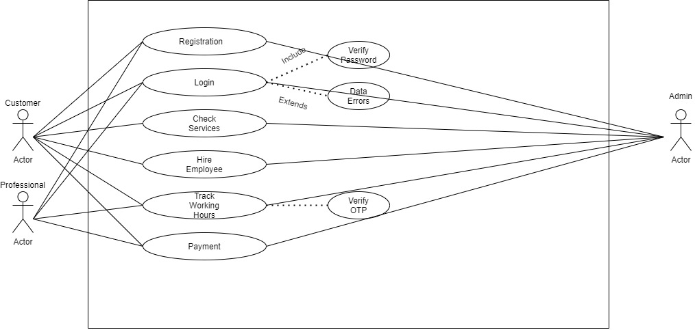

**User Case Diagram: a.2**

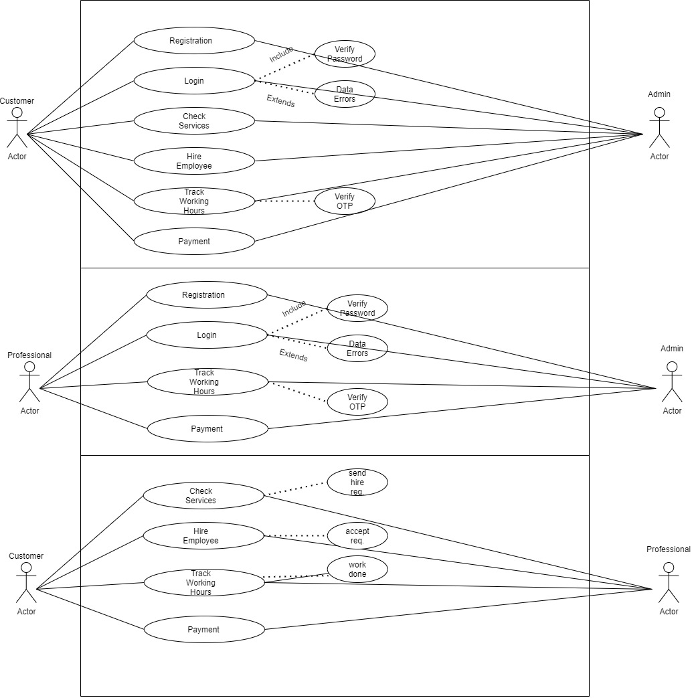

1. **Class Diagram**

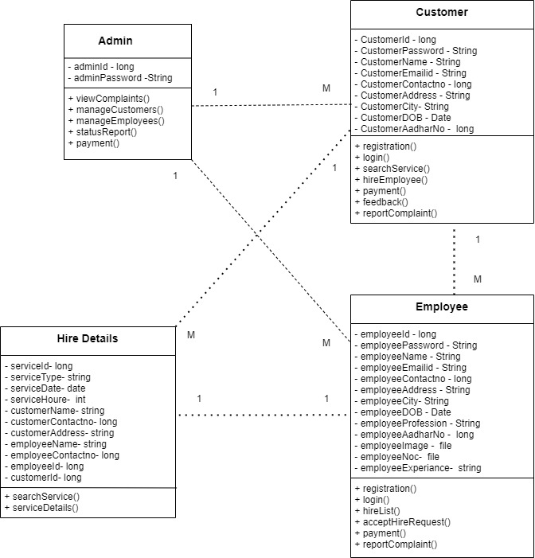

1. **Activity Diagram**

**Customer Activity Diagram: c.1**

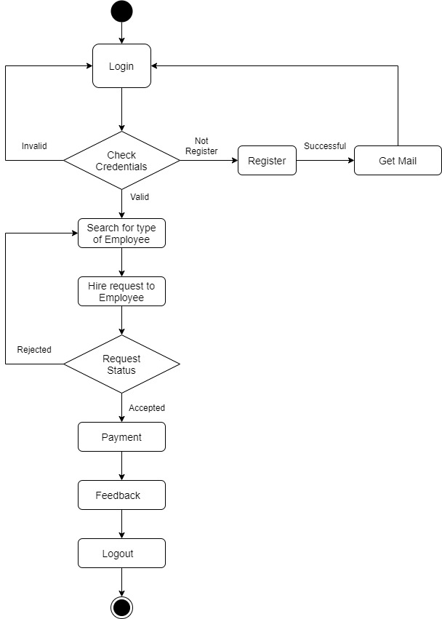

**Employee Activity Diagram: c.2**

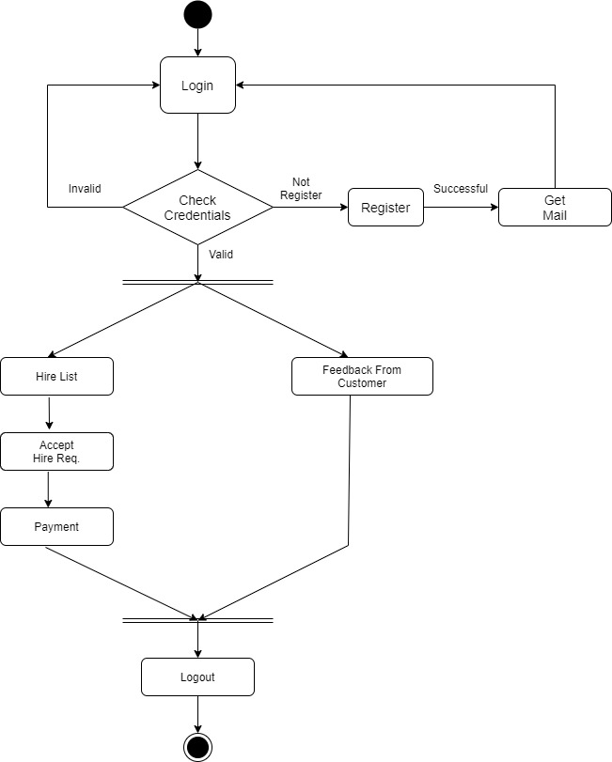

**Admin Activity Diagram: c.3**

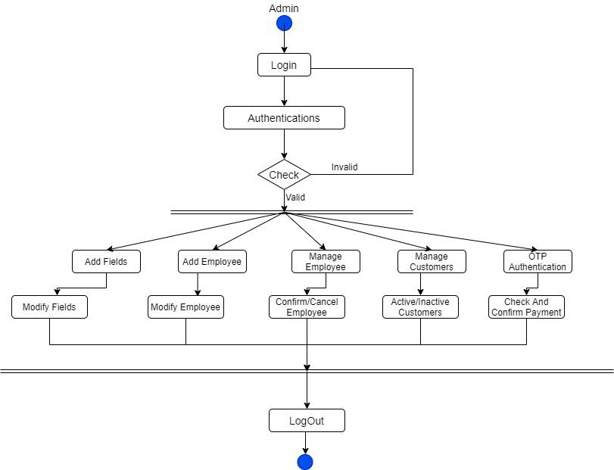

1. **Sequence Diagram:**

**Customer Sequence Diagram: d.1**

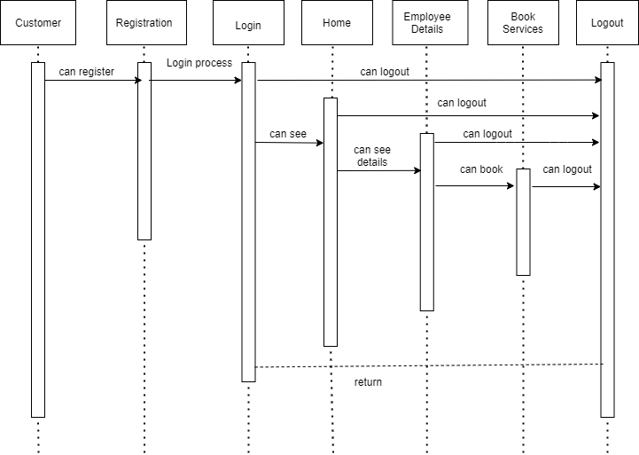

**Employee Sequence Diagram: d.2**

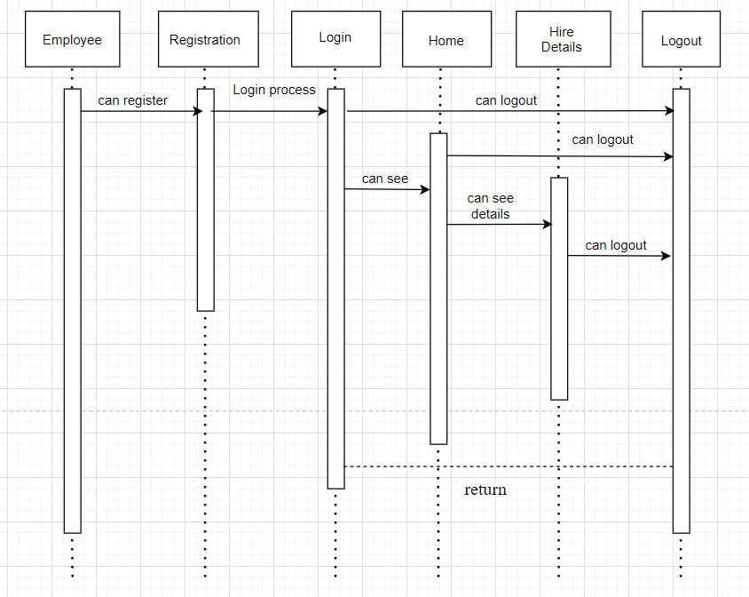

**Admin Sequence Diagram: d.3**

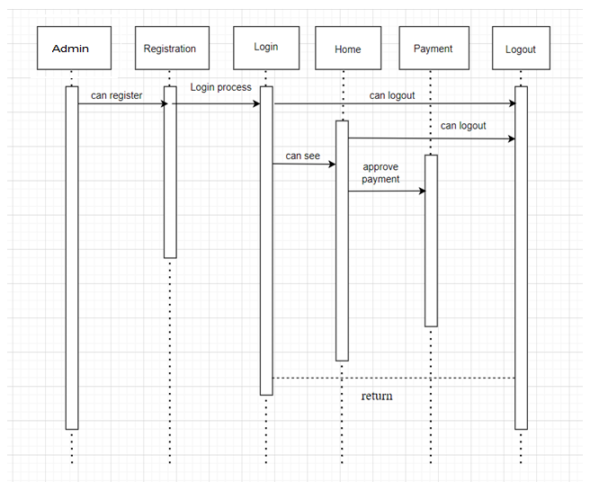

**SRS WORK REPORT:**

